A
Mini-Project Report on
AI-Based Explainable Resume Screening and Skill-Gap Analysis System
Submitted in partial fulfillment of the requirements for the award of the degree of

BACHELOR OF TECHNOLOGY

IN

COMPUTER SCIENCE AND ENGINEERING (DATA SCIENCE)

By

A.Nithisha(23R11A67A2)

Under the esteemed guidance of

Mr.K.Manoj Kumar
Assistant Professor



DEPARTMENT OF COMPUTER SCIENCE AND ENGINEERING (DATA SCIENCE)
Geethanjali College of Engineering and Technology
(UGC Autonomous)
Accredited by NAAC with A⁺ Grade; B.Tech. CSE, EEE, ECE accredited by NBA Sy. No: 33 & 34, Cheeryal (V), Keesara (M), Medchal District, Telangana – 501301
October 2026

Geethanjali College of Engineering and Technology (Autonomous)
Accredited by NAAC with A⁺ Grade; B.Tech. CSE, EEE, ECE accredited by NBA Sy. No: 33 & 34, Cheeryal (V), Keesara (M), Medchal District, Telangana – 501301

DEPARTMENT OF COMPUTER SCIENCE AND ENGINERING
(DATA SCIENCE)

Certificate

This is to certify that the mini project report entitled “AI-based explainable resume screening and skill-gap Analysis System” is a bonafide work done by A.Nithisha (23R11A67A2) in partial fulfillment of the requirements for the award of the degree of Bachelor of Technology in “Computer Science and Engineering (Data Science)” from Jawaharlal Nehru Technological University, Hyderabad during the year 2026-2027.

Internal Guide HOD - CSE(DS)
Mr.K.Manoj Kumar Dr D.Sujatha

Professor

Project Coordinator External Examiner
Dr. D. Bhanu Mahesh

Geethanjali College of Engineering and Technology (Autonomous)
Accredited by NAAC with A⁺ Grade; B.Tech. CSE, EEE, ECE accredited by NBA Sy. No: 33 & 34, Cheeryal (V), Keesara (M), Medchal District, Telangana – 501301

DEPARTMENT OF COMPUTER SCIENCE AND ENGINERING
(DATA SCIENCE)

DECLARATION BY THE CANDIDATE

I, A.Nithisha bearing Roll No. 23R11A67A2 hereby declare that the mini project report entitled “AI-Based Explainable Resume Screening and Skill-Gap Analysis System” is done under the guidance of Mr. K.Manoj Kumar, Assistant Professor, Department of Computer Science and Engineering (Data Science), Geethanjali College of Engineering and Technology, is submitted in partial fulfillment of the requirements for the award of the degree of Bachelor of Technology in CSE(Data Science).
This is a record of bonafide work carried out by us in Geethanjali College of Engineering and Technology and the results embodied in this project have not been reproduced or copied from any source. The results embodied in this project report have not been submitted to any other University or Institute for the award of any other degree or diploma.
A.Nithisha, 23R11A67A2,

Department of CSE(DS),

ACKNOWLEDGEMENTS
I would like to extend my sincere gratitude to our distinguished Chairman, Sri. G. R. Ravinder Reddy, whose steadfast support has been invaluable in the successful completion of our mini project. I also express our heartfelt gratitude to our esteemed Vice Chairman, Sri. K. Harish Chandra Reddy, for his valuable support and encouragement throughout this journey.
My sincere appreciation goes to our respected Director, Dr. S. Udaya Kumar, GCET, whose guidance and insights have been instrumental in shaping our seminar work. I am immensely grateful to our esteemed Principal, Dr. K. Sagar, GCET, for his unwavering support and direction during this entire process. Additionally, I extend my gratitude to Dr. V. Madhusudan Rao, Professor and Dean, School of Computer Science and Informatics, for his continuous support and motivation.
I extend my sincere appreciation to Dr. D. Sujatha, Professor and Head of the Department of CSE (DS), for her expertise, encouragement, and invaluable support, which have been instrumental in shaping our Mini Project’s direction and outcomes. I am also indebted to our Mini Project Coordinator, Dr. D. Bhanu Mahesh, CSE (DS), for his steadfast support and guidance throughout this journey. Furthermore, I express my heartful gratitude to our guide Mr.K.Manoj Kumar, Assisstant Professor, CSE (DS), for his insightful suggestions, continuous support, and invaluable mentorship, which have greatly contributed to the successful completion of our Mini Project.
Lastly, I would like to express my heartful gratitude to our friends and family for their unwavering support, understanding, and encouragement throughout this endeavor. Their patience and belief in me have been a constant source of motivation, and I am immensely grateful for their presence in our lives.
A.Nithisha, 23R11A67A2,

Department of CSE(DS),

Geethanjali College of Engineering and Technology (Autonomous)
Accredited by NAAC with A⁺ Grade; B.Tech. CSE, EEE, ECE accredited by NBA Sy. No: 33 & 34, Cheeryal (V), Keesara (M), Medchal District, Telangana – 501301

DEPARTMENT OF COMPUTER SCIENCE AND ENGINERING
(DATA SCIENCE)

Correlation Between The Mini Project and the Program Outcomes
(Po’s, Program Specific Outcomes (Pso’s)

IV YEAR I SEM SECTION – C  BATCH NO: 10 |  | TITLE OF THE MINI PROJECT
ROLL NO | NAME | AI-Based Explainable Resume Screening and Skill-Gap Analysis System
23R11A67A2 | A.Nithisha
23R11A67B6 | I.Shashank
23R11A67B9 | K.Anusha

Table 1: Mini Project coorelation with appropriate PO’s and PSO’s
(Please specify level of correlation, High – 3, Medium – 2 and Low – 1 )

COs/POs | PO1 | PO2 | PO3 | PO4 | PO5 | PO6 | PO7 | PO8 | PO9 | PO10 | PO11 | PO12
CO1 | 3 | 3 | 2 | 2 | 3 | 2 | – | 2 | 2 | 2 | 1 | 2
CO2 | 3 | 3 | 3 | 2 | 3 | 2 | – | 2 | 2 | 2 | 1 | 2
CO3 | 3 | 3 | 2 | 3 | 3 | - | – | - | 2 | 1 | – | 2
CO4 | 2 | 3 | 3 | 3 | 3 | 2 | - | 3 | 2 | 2 | – | 3
CO5 | 2 | 2 | 3 | 2 | 3 | 3 | 2 | 2 | 3 | 3 | 2 | 3

Internal Guide

Geethanjali College of Engineering and Technology (Autonomous)
Accredited by NAAC with A⁺ Grade; B.Tech. CSE, EEE, ECE accredited by NBA Sy. No: 33 & 34, Cheeryal (V), Keesara (M), Medchal District, Telangana – 501301

DEPARTMENT OF COMPUTER SCIENCE AND ENGINERING
(DATA SCIENCE)

Sustainable Development Goals (SDG) Table for AI-Based Explainable Resume Screening and Skill-Gap Analysis System.

SDG No. | SDG Names | Relevance to mini Project | Level
SDG 9 | Industry, Innovation and Infrastructure | Uses AI, Machine Learning, NLP, and web technologies to develop an intelligent recruitment-support application. | Secondary
SDG 8 | Decent Work and Economic Growth | Supports efficient and skill-based recruitment by automating initial resume screening and identifying suitable candidates. | Primary
SDG 10 | Reduced Inequalities | Supports consistent and transparent initial screening using job-related skills, matched skills, missing skills, and explainable results. | Supporting

ABSTRACT

The AI-Based Explainable Resume Screening and Skill-Gap Analysis System is an intelligent application developed to automate the initial resume screening process. The system uses Artificial Intelligence and Natural Language Processing (NLP) to compare candidate resumes with a given job description and identify suitable candidates.
The system uses text preprocessing, TF-IDF, and Cosine Similarity to calculate the matching score and rank candidates. In addition to providing a match percentage, the proposed system identifies matched skills, missing skills, and skill gaps for each candidate. It also provides an explanation of the candidate's score and suggests areas for improvement.
A Streamlit-based web interface allows recruiters to upload job descriptions and multiple resumes and view the screening results through candidate rankings, skill analysis, and explainable results. The results are presented in a simple and understandable format so that recruiters can quickly compare candidates and identify their strengths and areas that require improvement.The main focus of the project is to make resume screening more transparent and informative rather than depending only on a single similarity score. By combining candidate matching, skill-gap identification, and explainable analysis in one application, the system provides useful decision support during the initial recruitment stage while keeping the final hiring decision with the recruiter.

Table of Contents

S. No. | Contents | Page No.
1. | Abstract | 7
2. | Introduction | 11
3. | Literature Review | 12
4. | Design  System Architecture  UML Diagrams  Use case Diagram  Activity Diagram  Sequence Diagram  Class Diagram | 13
5. | Methodology | 20
6. | Implementation | 21
7. | Results & Analysis | 33
8. | Testing and Test cases | 36
9. | Conclusion and Future work | 37
10. | References | 38
11. | Appendices | 39

List of Figures

S.No. | Figure Name | Page No.
1. | System Architecture Flow | 15
2. | Use Case Diagram | 16
3. | Activity Diagram | 17
6. | Sequence Diagram | 18
7. | Class Diagram | 19
8. | Implementation-Coding | 21
9. | Results & Analysis | 33

List of Tables

S.No. | Table Name | Page No.
1. | CO–PO/PSO Mapping | 5
2. | SDG Mapping | 6
3. | Literature Review | 12
4. | Testing and Test Cases | 36

INTRODUCTION

In today’s competitive job market, organizations receive a large number of resumes for every job position. Manually reviewing and comparing these resumes with job requirements can be a time-consuming and challenging process. Recruiters need to identify relevant skills, qualifications, and experience from each resume while ensuring that suitable candidates are not overlooked. At the same time, candidates may not clearly understand which skills they are missing for a particular job role.

The AI-Based Explainable Resume Screening and Skill-Gap Analysis System is developed to address these challenges by using Artificial Intelligence (AI), Natural Language Processing (NLP), and text analysis techniques. The system automatically processes a candidate’s resume and extracts important information such as technical skills, educational qualifications, experience, and other relevant details. It also analyzes the provided job description to identify the skills and requirements expected for the position.

The extracted information from the resume and job description is then compared to determine the level of compatibility between the candidate and the job. The system generates a resume–job match score based on the identified skills and requirements. Along with the score, it highlights the skills that match the job requirements and identifies the skill gaps, helping the candidate understand areas where improvement may be needed.

An important feature of this system is Explainable AI (XAI). Instead of simply displaying a final score, the system provides understandable reasons for the result, such as matched skills, missing skills, and factors contributing to the match. This makes the screening process more transparent and helps users understand how the system reached its conclusion.

The proposed system can therefore support both recruiters and job seekers. Recruiters can reduce the effort involved in initial resume screening, while candidates can use the skill-gap analysis to identify areas for learning and improvement. Overall, the project aims to provide a simple, efficient, transparent, and user-friendly approach to AI-assisted resume screening and career-oriented skill analysis.

LITERATURE REVIEW

S.No. | Title of the Paper | Author of the Paper | Methodology Used | Drawbacks of Their Methodology | Research Gap / Gap Identified
1 | End-to-End Resume Parsing and Finding Candidates for a Job Description using BERT | Vedant Bhatia, Prateek Rawat, Ajit Kumar, Rajiv Ratn Shah | Uses a resume parser to extract information from resumes and BERT sentence-pair classification to rank candidates according to job descriptions. | Focuses mainly on resume parsing and candidate ranking; does not provide detailed skill-gap analysis or user-friendly explanations of the ranking. | Need for an integrated system that provides skill gaps, matched skills, and understandable explanations along with the matching score.
2 | Optimizing Job Matching Through Automated Resume Screening with NLP and Machine Learning | Authors of the IEEE INSPECT 2024 study | Uses tokenization, stemming, lemmatization, TF-IDF, string matching, and ML models such as SVM, Logistic Regression, Random Forest, and KNN for resume screening and job-role classification. | Keyword-based techniques may have difficulty understanding the deeper semantic relationship between a resume and a job description. | Need for semantic matching and explainable results instead of depending mainly on keywords and classification.

Research Gap

From these studies, we can identify that existing systems generally concentrate on resume parsing, keyword/semantic matching, candidate ranking, or explainability. Some recent systems combine several of these features, but there is still scope for a simple integrated system that combines:
Resume Processing → Skill Extraction → Job Matching → Match Score → Skill-Gap Analysis → Explainable Results
Your project can therefore focus on making the results easy to understand for the candidate rather than simply producing a ranking or numerical score.

DESIGN

System Design

The proposed AI-Based Explainable Resume Screening and Skill-Gap Analysis System is designed as an intelligent application that analyzes candidate resumes and compares them with job descriptions using Artificial Intelligence (AI), Natural Language Processing (NLP), machine learning techniques, and explainable analysis. The system follows a modular architecture in which each module performs a specific task, such as resume processing, skill extraction, job matching, skill-gap identification, and result explanation. This modular design improves the system's efficiency, maintainability, scalability, and transparency.
Initially, the user provides a resume and job description through the application interface. The resume may contain information such as educational qualifications, technical skills, projects, certifications, and work experience. The submitted resume is first processed to extract readable text from the document. The extracted information is then cleaned and normalized by removing unnecessary characters, formatting issues, and irrelevant content. Similarly, the job description is processed to identify the important requirements and skills associated with the particular job role.

The processed resume and job description are then passed to the NLP and Skill Extraction Module. This module analyzes the textual information and identifies relevant skills, technologies, programming languages, qualifications, and other job-related information. A skills database can also be used to recognize commonly used technical and professional skills. The extracted information provides a structured representation of both the candidate's profile and the job requirements.
The Resume–Job Matching Module then compares the skills and qualifications extracted from the resume with those identified from the job description. Based on the level of similarity and the number of relevant skills identified, the system generates a matching score. The system also separates the candidate's skills into matched and unmatched categories, allowing the user to understand which requirements are already satisfied.

System Architecture

Architecture Description:

The architecture of the proposed AI-Based Explainable Resume Screening and Skill-Gap Analysis System consists of multiple interconnected modules that work together to analyze resumes, match them with job descriptions, and identify skill gaps.

1. User Interface

Allows users to upload resumes and enter/upload job descriptions.

Provides an interface to initiate the resume screening process.

2. Resume Processing Module

Extracts text from uploaded PDF/resume files.

Cleans and normalizes the extracted text.

3. NLP / AI Module

Performs Natural Language Processing on resumes and job descriptions.

Extracts relevant skills, qualifications, tools, and technologies.

4. Resume–Job Matching Module

Compares candidate skills with job-required skills.

Identifies matched and relevant skills.

5. Skill-Gap Analysis Module

Identifies skills required by the job but missing from the resume.

Highlights the candidate's skill gaps.

6. Explainable AI Module

Explains the reasons behind the generated match score.

Displays matched skills and missing skills.

7. Skills Database

Stores commonly used technical and professional skills.

Contains information related to skills and job roles.

8. Results / Dashboard Module

Displays the final match score.

Shows matched skills and identified skill gaps.

System Architecture Flow

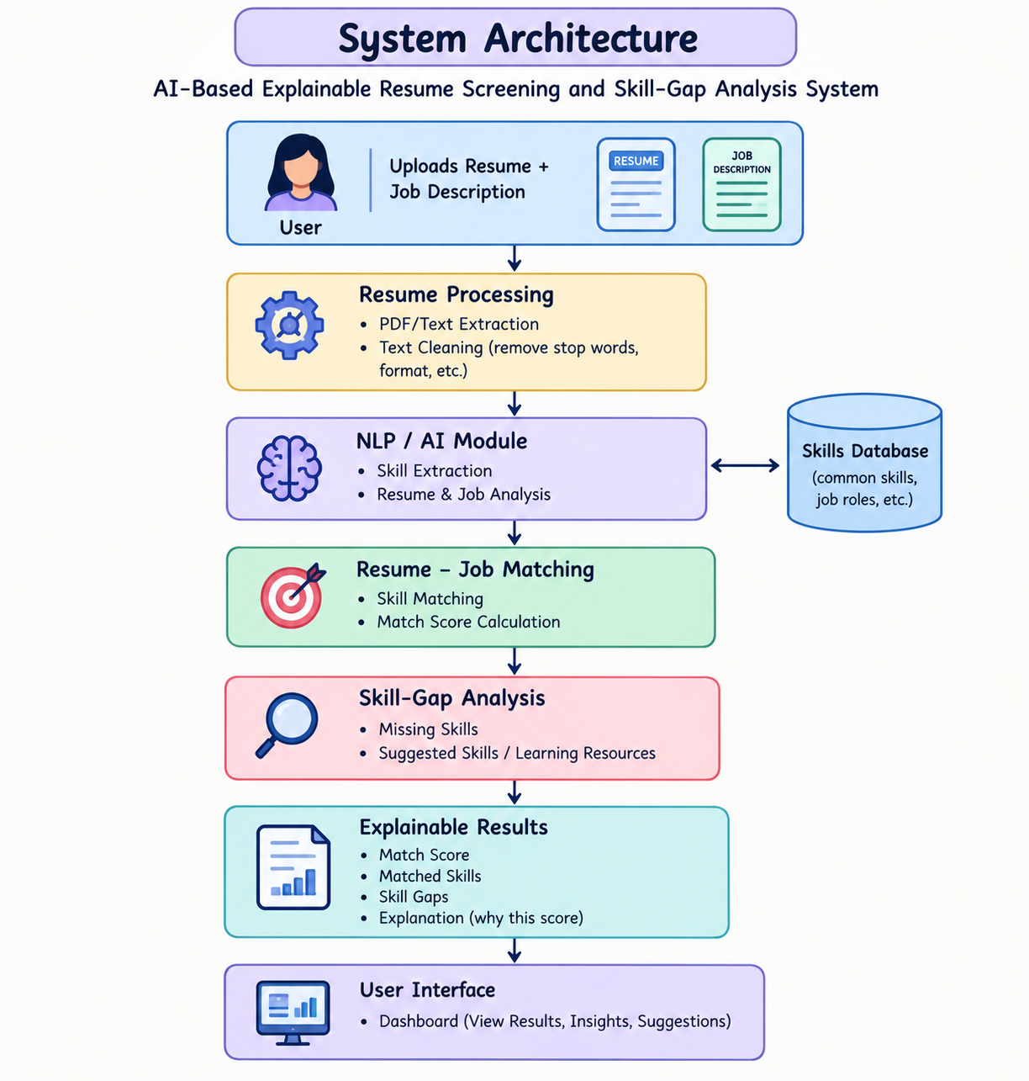

UML DIAGRAMS

USE CASE DIAGRAM
Description: The Use Case Diagram represents how candidates and recruiters interact with the AI-based resume screening system.
Candidates can upload resumes, enter job descriptions, view results, and receive skill-gap recommendations, while recruiters can analyze candidates, compare profiles, and download reports.

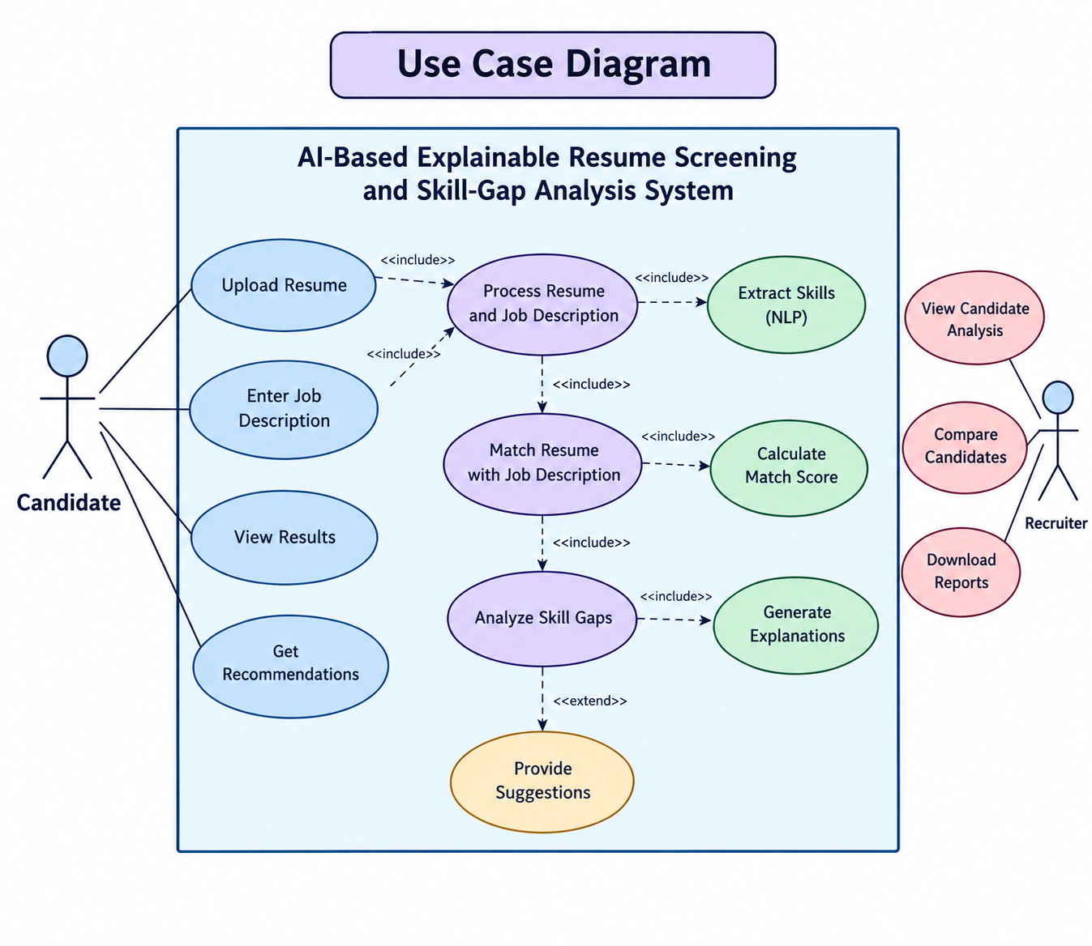

ACTIVITY DIAGRAM
Description: The Activity Diagram represents the workflow of the AI-based resume screening system, from uploading resumes and job descriptions to candidate ranking, skill-gap analysis, and generating explainable results.

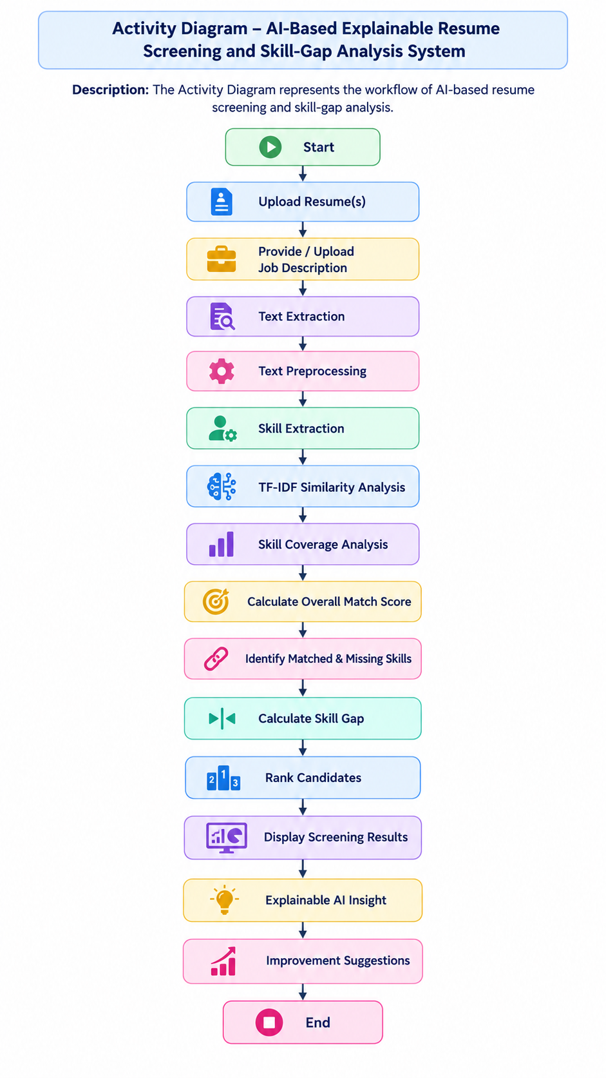

SEQUENCE DIAGRAM
Description: The Sequence Diagram represents the interaction between the user, web application, backend, and AI/NLP modules during resume analysis, scoring, ranking, and skill-gap identification.

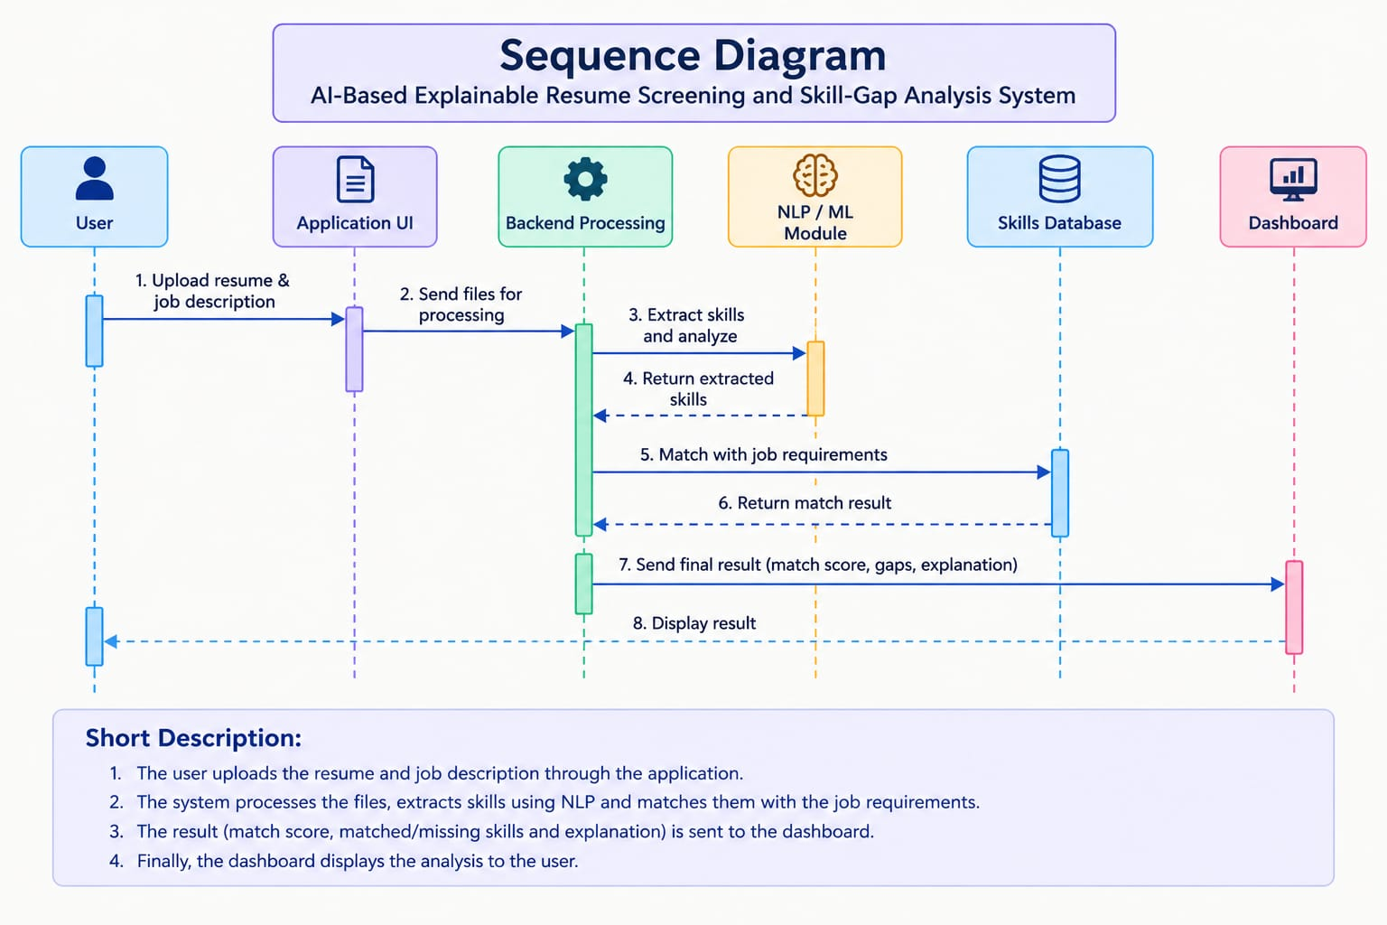

CLASS DIAGRAM
Description: The Class Diagram represents the static structure of the AI-based resume screening system, showing the main classes such as User, Resume, Job Description, Resume Analyzer, Skill Extractor, and Screening Result along with their attributes and relationships.

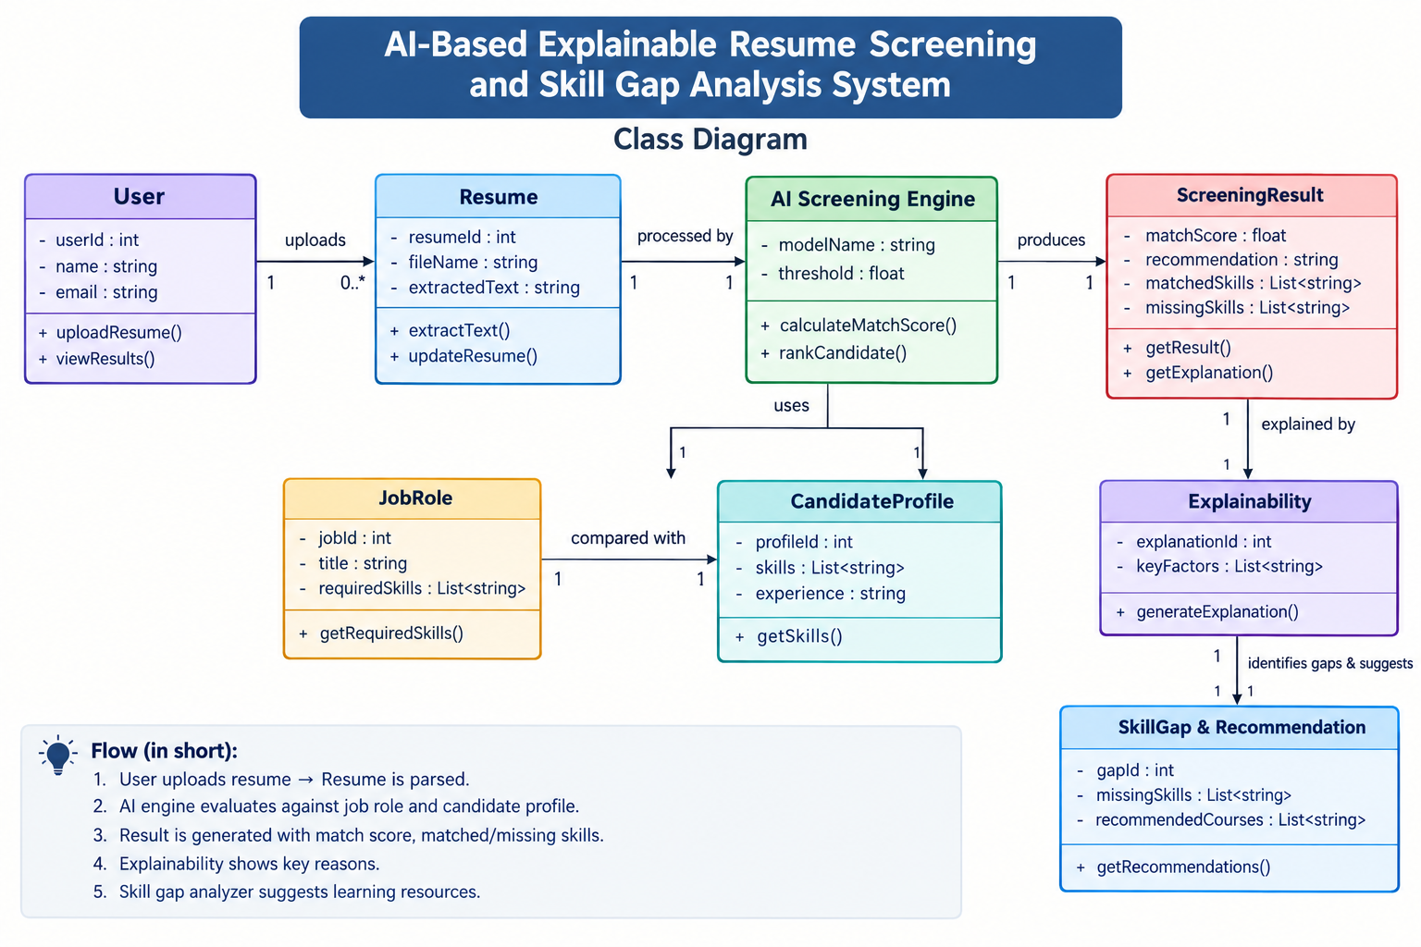

METHODOLOGY

The methodology of the proposed AI-Based Explainable Resume Screening and Skill-Gap Analysis System consists of a sequence of processes that transform an uploaded resume and job description into an understandable candidate analysis. The system combines Natural Language Processing (NLP), Artificial Intelligence, skill extraction, resume–job matching, and Explainable AI techniques.

1. Input Collection
The system accepts two primary inputs from the user:
- Candidate Resume
- Job Description

2. Resume and Job Description Processing
The uploaded resume is converted into machine-readable text. The extracted text is cleaned and normalized by removing unnecessary characters, formatting elements, and irrelevant information. The same preprocessing procedure is applied to the job description so that both inputs can be analyzed consistently.

3. Skill Extraction Using NLP
NLP techniques are applied to identify important information from the processed text. The system extracts:
- Technical skills
- Programming languages
- Tools and technologies
- Educational qualifications
- Relevant experience
- Job-related keywords

5. Skill-Gap Analysis
The system compares the candidate's existing skills with the skills required for the job. Skills that are required but not found in the resume are identified as skill gaps

6. Explainable AI
The system provides an explanation along with the match score. Instead of showing only a numerical result, it presents:
- Matched skills
- Missing skills
- Important job requirements
- Factors contributing to the result
- Explanation of the generated score

7. Result Generation
The final results are presented through a user-friendly dashboard. The dashboard displays the match score, matched skills, skill gaps, explanations, and recommendations in an organized format.

Implementation – Coding

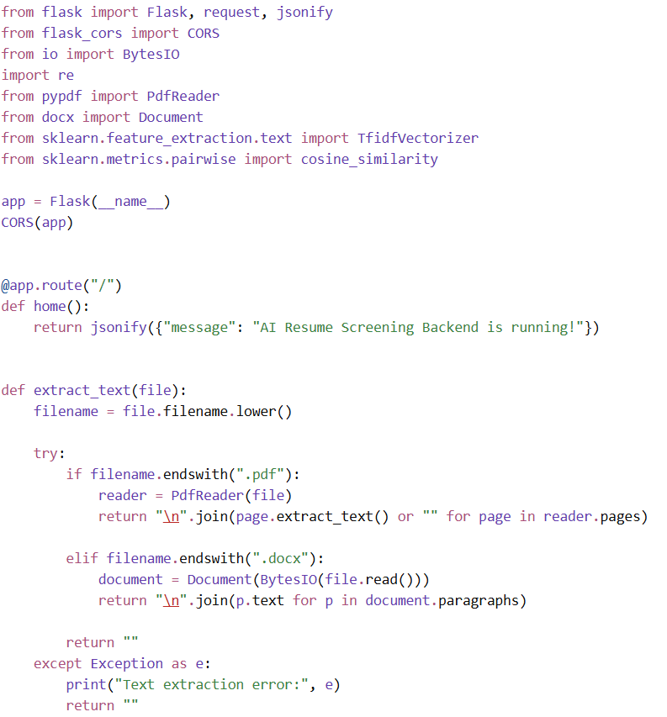

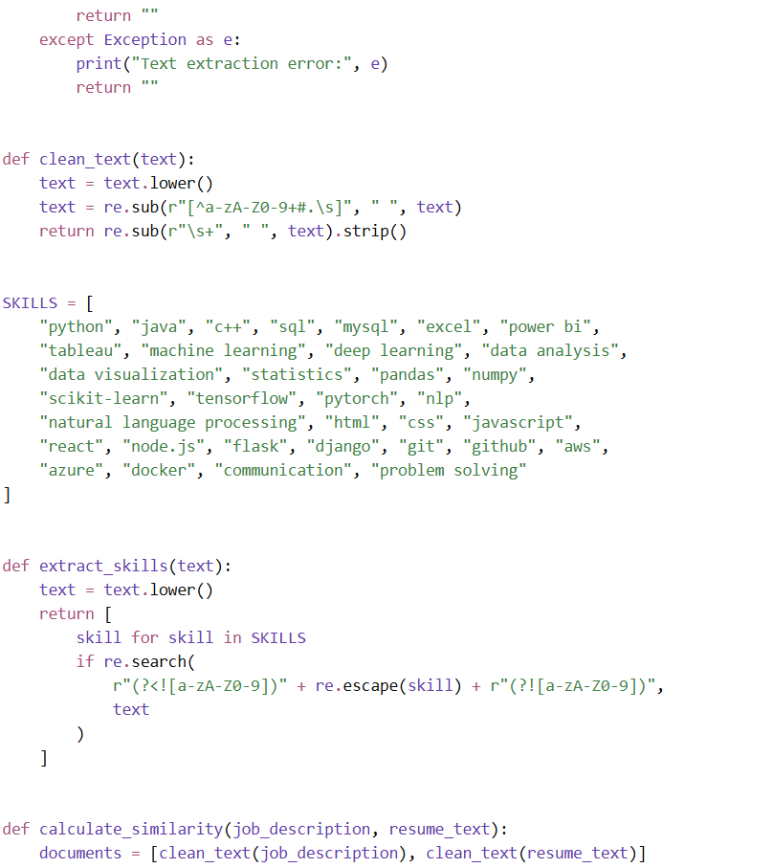

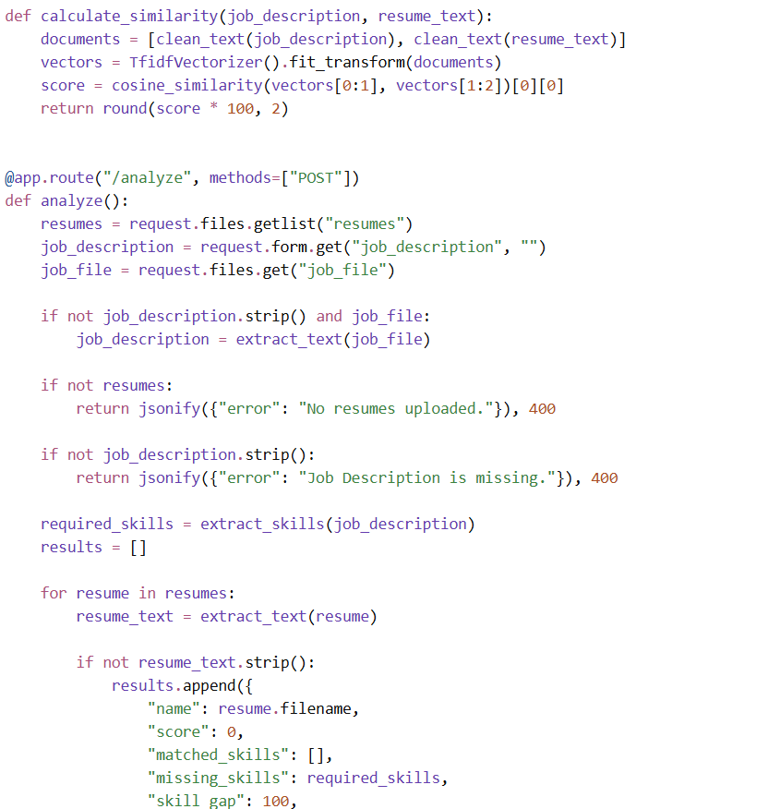

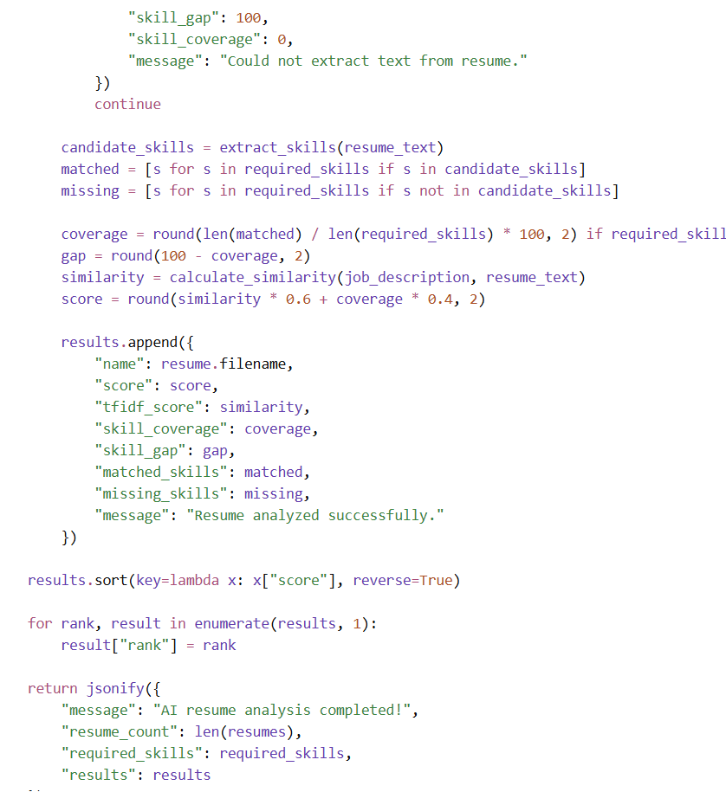

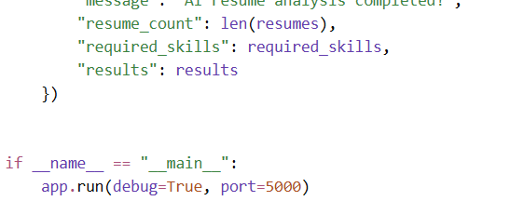

Main.js

import "./style.css";

document.querySelector("#app").innerHTML = `
<div class="app-shell">
<aside class="sidebar">
<div class="brand"><div class="brand-icon">🤖</div><div><h2>ResumeAI</h2><span>Smart Screening</span></div></div>
<nav class="sidebar-nav">
<button class="nav-item active">▦ Dashboard</button>
<button class="nav-item" id="uploadNav">↑ Upload Resumes</button>
<button class="nav-item">▤ Job Description</button>
<button class="nav-item">◉ View Results</button>
<button class="nav-item">⚙ Settings</button>
</nav>
<div class="sidebar-bottom"><div class="ai-status"><span class="status-dot"></span> AI Engine Active</div></div>
</aside>
<main class="main-content">
<header class="topbar"><div><p class="small-label">AI RECRUITMENT PLATFORM</p><h1>Resume Analysis Dashboard</h1><p class="subtitle">Analyze and rank candidates using AI.</p></div><div class="top-badge">● Screening Ready</div></header>
<section class="upload-panel" id="uploadSection">
<div class="section-heading"><div><h2>Start Candidate Screening</h2><p>Upload resumes and provide a job description.</p></div></div>
<div class="upload-grid">
<div class="upload-box"><div class="upload-icon">📄</div><h3>Upload Resumes</h3><p>Upload up to 5 PDF or DOCX resumes</p><input type="file" id="resumeInput" multiple accept=".pdf,.docx"><label for="resumeInput" class="upload-button">Choose Resumes</label><div id="resumeList" class="file-list"></div></div>
<div class="upload-box"><div class="upload-icon">💼</div><h3>Job Description</h3><p>Upload JD or paste below</p><input type="file" id="jobFileInput" accept=".pdf,.docx"><label for="jobFileInput" class="upload-button secondary">Upload JD</label><textarea id="jobDescription" placeholder="Paste job description..."></textarea><div id="jobFileName" class="file-name"></div></div>
</div>
<button id="analyzeBtn" class="analyze-button" disabled>✨ Analyze Candidates</button>
<div id="analysisMessage"></div>
</section>
</main>
</div>`;

const $ = id => document.getElementById(id);
const resumeInput = $("resumeInput"), jobFileInput = $("jobFileInput");
const jobDescription = $("jobDescription"), resumeList = $("resumeList");
const jobFileName = $("jobFileName"), analyzeBtn = $("analyzeBtn");
const analysisMessage = $("analysisMessage");

let resumes = [], jobFile = null;
window.screeningResults = [];

function updateButton() {
analyzeBtn.disabled = !resumes.length ||
(!jobDescription.value.trim() && !jobFile);
}

function renderResumes() {
resumeList.innerHTML = "";
resumes.forEach((file, i) => {
const row = document.createElement("div");
row.className = "file-item";
const name = document.createElement("span");
name.textContent = "📄 " + file.name;
const remove = document.createElement("button");
remove.textContent = "×";
remove.type = "button";
remove.onclick = () => {
resumes.splice(i, 1);
renderResumes();
updateButton();
};
row.append(name, remove);
resumeList.appendChild(row);
});
}

resumeInput.onchange = () => {
resumes = Array.from(resumeInput.files).slice(0, 5);
renderResumes();
updateButton();
};

jobFileInput.onchange = () => {
jobFile = jobFileInput.files[0] || null;
jobFileName.textContent = jobFile ? "✓ " + jobFile.name : "";
updateButton();
};

jobDescription.oninput = updateButton;

$("uploadNav").onclick = () =>
$("uploadSection").scrollIntoView({ behavior: "smooth" });

analyzeBtn.onclick = async () => {
if (!resumes.length) return alert("Upload at least one resume.");
if (!jobDescription.value.trim() && !jobFile)
return alert("Provide a job description.");

analyzeBtn.disabled = true;
analyzeBtn.textContent = "Analyzing...";
analysisMessage.textContent = "⏳ AI is analyzing candidates...";

const form = new FormData();
resumes.forEach(file => form.append("resumes", file));
form.append("job_description", jobDescription.value);
if (jobFile) form.append("job_file", jobFile);

try {
const response = await fetch("http://127.0.0.1:5000/analyze", {
method: "POST",
body: form
});
const data = await response.json();
if (!response.ok) throw new Error(data.error || "Analysis failed.");

window.screeningResults = data.results || [];
showResults(data);
} catch (error) {
analysisMessage.textContent = "⚠ " + error.message;
} finally {
analyzeBtn.textContent = "✨ Analyze Candidates";
updateButton();
}
};

function showResults(data) {
const results = data.results || [];
const scores = results.map(c => Number(c.score || 0));
const average = scores.length
? (scores.reduce((a, b) => a + b, 0) / scores.length).toFixed(1)
: "0";
const best = scores.length ? Math.max(...scores).toFixed(1) : "0";

analysisMessage.innerHTML = `
<div class="results-dashboard">
<div class="results-header"><div><p class="small-label">SCREENING RESULTS</p><h2>Candidate Overview</h2></div><button id="newAnalysisBtn" class="new-analysis-btn">+ New Analysis</button></div>
<div class="summary-grid">
<div class="summary-card"><span>Total Candidates</span><strong>${results.length}</strong></div>
<div class="summary-card"><span>Average Match</span><strong>${average}%</strong></div>
<div class="summary-card"><span>Best Match</span><strong>${best}%</strong></div>
<div class="summary-card"><span>Required Skills</span><strong>${data.required_skills?.length || 0}</strong></div>
</div>
<div class="candidate-section"><h3>Ranked Candidates</h3><div class="candidate-grid">${results.map(card).join("")}</div></div>
<div id="candidateDetails"></div></div>`;

document.querySelectorAll(".view-details-btn").forEach(btn =>
btn.onclick = () => showDetails(Number(btn.dataset.rank))
);

$("newAnalysisBtn").onclick = () => {
analysisMessage.innerHTML = "";

$("uploadSection").scrollIntoView({ behavior: "smooth" });
};
}

function card(c) {
const score = Number(c.score || 0);
const skills = (items, type) => items.length
? items.slice(0, 5).map(s => `<span class="skill ${type}">${s}</span>`).join("")
: "None";

return `<div class="candidate-card">
<div class="candidate-top"><div class="rank-badge">#${c.rank}</div><div class="candidate-name-area"><h3>${c.name}</h3><span>Candidate ${c.rank}</span></div><div class="score-ring ${score >= 80 ? "excellent" : score >= 60 ? "good" : "average"}"><strong>${score.toFixed(1)}%</strong><span>Match</span></div></div>
<div class="metric-row">
<div class="metric"><span>TF-IDF Match</span><strong>${Number(c.tfidf_score || 0).toFixed(1)}%</strong></div>
<div class="metric"><span>Skill Coverage</span><strong>${Number(c.skill_coverage || 0).toFixed(1)}%</strong></div>
<div class="metric"><span>Skill Gap</span><strong>${Number(c.skill_gap || 0).toFixed(1)}%</strong></div></div>
<div class="skill-preview">
<div class="skill-column"><h4>🟢 Matched Skills</h4><div class="skill-tags">${skills(c.matched_skills || [], "matched")}</div></div>
<div class="skill-column"><h4>🔴 Missing Skills</h4><div class="skill-tags">${skills(c.missing_skills || [], "missing")}</div></div></div>
<button class="view-details-btn" data-rank="${c.rank}">View Candidate Details →</button></div>`;
}

function showDetails(rank) {
const c = window.screeningResults.find(x => Number(x.rank) === rank);
if (!c) return;

const matched = c.matched_skills || [], missing = c.missing_skills || [];
const total = matched.length + missing.length;
const percent = total ? Math.round(matched.length / total * 100) : 0;
const score = Number(c.score || 0);
const suggestion = score >= 80
? "Strong candidate. Improve the remaining missing skills."
: score < 60
? "Develop the missing skills to improve job readiness."
: "Improve the missing skills to increase job compatibility.";

const tags = (items, type) => items.length
? items.map(s => `<span class="skill ${type}">${s}</span>`).join("")
: "None";

$("candidateDetails").innerHTML = `
<div class="details-panel">
<div class="details-header"><div><span class="details-label">CANDIDATE DETAILS</span><h2>${c.name}</h2><p>Rank #${c.rank}</p></div><div class="large-score"><strong>${score.toFixed(1)}%</strong><span>Overall Match</span></div></div>
<div class="details-stats">
<div><span>TF-IDF Similarity</span><strong>${Number(c.tfidf_score || 0).toFixed(1)}%</strong></div>

<div><span>Skill Coverage</span><strong>${Number(c.skill_coverage || 0).toFixed(1)}%</strong></div>
<div><span>Skill Gap</span><strong>${Number(c.skill_gap || 0).toFixed(1)}%</strong></div></div>
<div class="details-box"><h3>Skill Coverage: ${percent}%</h3><p>Matched: ${matched.length} | Missing: ${missing.length}</p><div style="height:12px;background:#ef6b73;border-radius:8px;overflow:hidden"><div style="height:100%;width:${percent}%;background:#27b77a"></div></div></div>
<div class="details-box"><h3>✓ Matched Skills</h3><div class="large-skill-list">${tags(matched, "matched")}</div></div>
<div class="details-box"><h3>! Missing Skills</h3><div class="large-skill-list">${tags(missing, "missing")}</div></div>
<div class="explain-box"><h3>💡 Explainable AI Insight</h3><p>Overall score combines 60% TF-IDF similarity and 40% skill coverage.</p></div>
<div class="improvement-box"><h3>🚀 Improvement Suggestion</h3><p>${suggestion}</p></div>
</div>`;

$("candidateDetails").scrollIntoView({ behavior: "smooth" });
}

updateButton();

Style.Css

*{box-sizing:border-box}
html{scroll-behavior:smooth}
body{margin:0;font-family:Inter,"Segoe UI",Arial,sans-serif;background:#f5f7fb;color:#182230}
button,input,textarea{font-family:inherit}
.app-shell{min-height:100vh;display:flex}
.sidebar{width:245px;min-height:100vh;background:#fff;border-right:1px solid #e8ecf3;padding:28px 18px;display:flex;flex-direction:column;position:fixed;inset:0 auto 0 0;z-index:10}
.brand{display:flex;align-items:center;gap:12px;padding:5px 10px 35px}
.brand-icon{width:44px;height:44px;border-radius:13px;display:flex;align-items:center;justify-content:center;background:linear-gradient(135deg,#6257f5,#8b7cff);color:#fff;font-size:22px}
.brand h2{margin:0;font-size:20px;letter-spacing:-.5px}
.brand span{display:block;color:#8a94a6;font-size:11px;margin-top:3px}
.sidebar-nav{display:flex;flex-direction:column;gap:7px}
.nav-item{border:0;background:transparent;padding:13px 14px;border-radius:11px;text-align:left;color:#687386;cursor:pointer;font-size:14px;display:flex;gap:13px;align-items:center;transition:.2s}
.nav-item span{font-size:17px;width:20px}
.nav-item:hover,.nav-item.active{background:#efedff;color:#6257f5}
.nav-item.active{font-weight:600}
.sidebar-bottom{margin-top:auto;padding:10px}
.ai-status{background:#f5f8f7;border:1px solid #e5eee9;padding:12px;border-radius:11px;font-size:12px;color:#607168}
.status-dot,.green-dot,.red-dot{display:inline-block;border-radius:50%}
.status-dot{width:8px;height:8px;background:#29b77a;margin-right:7px}
.main-content{margin-left:245px;width:calc(100% - 245px);min-height:100vh;padding:35px 45px 60px}
.topbar{display:flex;justify-content:space-between;align-items:flex-start;margin-bottom:32px}
.small-label{color:#7167e8;font-size:11px;font-weight:700;letter-spacing:1.5px;margin:0 0 7px}
.topbar h1{font-size:32px;margin:0;letter-spacing:-1px}
.subtitle{color:#7b8495;margin:9px 0 0;font-size:14px}
.top-badge{background:#fff;border:1px solid #e5e9f1;padding:10px 15px;border-radius:20px;font-size:12px;color:#596474}
.top-badge span{color:#2bb67b;margin-right:5px}
.upload-panel{background:#fff;border:1px solid #e6eaf1;border-radius:20px;padding:30px;box-shadow:0 8px 30px #1e28460d}
.section-heading h2{margin:0;font-size:21px}
.section-heading p{color:#8992a2;font-size:13px;margin:7px 0 25px}
.upload-grid{display:grid;grid-template-columns:1fr 1fr;gap:22px}
.upload-box{border:1.5px dashed #d7dce7;border-radius:16px;padding:25px;text-align:center;background:#fafbfe}
.upload-icon{font-size:31px;margin-bottom:8px}
.upload-box h3{margin:0 0 5px;font-size:16px}
.upload-box p{color:#8a94a5;font-size:12px;margin:0 0 17px}
.upload-box input[type=file]{display:none}
.upload-button{display:inline-block;background:#6257f5;color:#fff;padding:10px 18px;border-radius:9px;font-size:12px;font-weight:600;cursor:pointer}
.upload-button.secondary{background:#343c4b}
textarea{display:block;width:100%;height:90px;margin-top:15px;resize:vertical;border:1px solid #e1e5ed;border-radius:10px;padding:11px;outline:none;font-size:12px}
textarea:focus{border-color:#766cf1}
.file-list{margin-top:13px}
.file-item{background:#fff;border:1px solid #e7eaf0;border-radius:8px;padding:7px 9px;margin-top:5px;display:flex;gap:7px;align-items:center;font-size:11px;text-align:left}
.file-item span:nth-child(2){flex:1}
.file-item button{border:0;background:transparent;color:#9aa2af;cursor:pointer}
.file-name{color:#2da875;font-size:12px;margin-top:10px}
.analyze-button{display:block;margin:25px auto 0;border:0;background:linear-gradient(135deg,#6257f5,#8176ff);color:#fff;padding:13px 30px;border-radius:10px;font-size:13px;font-weight:600;cursor:pointer;box-shadow:0 8px 18px #6257f533}
.analyze-button:disabled{opacity:.45;cursor:not-allowed}
.loading-box,.error-box{margin-top:25px;padding:30px;text-align:center;border-radius:15px;background:#fafbfe}
.loading-box h3{margin:15px 0 5px}
.loading-box p{color:#8a94a4;font-size:13px}
.big-loader{width:40px;height:40px;border:4px solid #e6e4ff;border-top-color:#6257f5;border-radius:50%;margin:auto;animation:spin .8s linear infinite}
@keyframes spin{to{transform:rotate(360deg)}}
.error-box{color:#b42318;background:#fff5f4}
.results-dashboard{width:100%;margin-top:5px}
.results-header{display:flex;justify-content:space-between;align-items:flex-end;margin:38px 0 22px}
.results-header h2{font-size:27px;margin:0}
.results-header p:not(.small-label){margin:6px 0 0;color:#8790a0;font-size:13px}
.new-analysis-btn{background:#fff;border:1px solid #dfe4ec;border-radius:9px;padding:10px 16px;cursor:pointer;color:#566071;font-size:12px;font-weight:600}
.summary-grid{display:grid;grid-template-columns:repeat(4,1fr);gap:17px;margin-bottom:30px}
.summary-card{background:#fff;border:1px solid #e6eaf1;border-radius:15px;padding:19px;display:flex;align-items:center;gap:14px;box-shadow:0 5px 18px #1e284609}
.summary-icon{width:43px;height:43px;border-radius:11px;display:flex;align-items:center;justify-content:center;font-size:18px}
.summary-icon.blue{background:#edf4ff}.summary-icon.green{background:#eaf9f2}.summary-icon.purple{background:#f0edff}.summary-icon.orange{background:#fff5e8}
.summary-card span{display:block;color:#8992a1;font-size:11px;margin-bottom:4px}
.summary-card strong{font-size:22px}
.candidate-section{background:transparent}
.section-title-row{display:flex;justify-content:space-between;align-items:flex-end;margin-bottom:17px}
.section-title-row h3{margin:0;font-size:19px}
.section-title-row p{margin:5px 0 0;color:#8a93a2;font-size:12px}
.candidate-count{background:#eeecff;color:#6257f5;padding:7px 11px;border-radius:15px;font-size:11px;font-weight:600}
.candidate-grid{display:grid;grid-template-columns:repeat(3,minmax(0,1fr));gap:18px}
.candidate-card{background:#fff;border:1px solid #e5e9f0;border-radius:17px;padding:21px;box-shadow:0 6px 20px #1e28460b;transition:transform .2s,box-shadow .2s}
.candidate-card:hover{transform:translateY(-3px);box-shadow:0 12px 28px #1e284617}
.candidate-top{display:flex;align-items:center;gap:10px}
.rank-badge{width:35px;height:35px;border-radius:10px;background:#f0eeff;color:#6257f5;display:flex;align-items:center;justify-content:center;font-size:12px;font-weight:700}
.candidate-name-area{min-width:0;flex:1}
.candidate-name-area h3{margin:0;font-size:14px;white-space:nowrap;overflow:hidden;text-overflow:ellipsis}
.candidate-name-area span{color:#949cab;font-size:10px}
.score-ring{width:58px;height:58px;border-radius:50%;display:flex;flex-direction:column;align-items:center;justify-content:center;flex-shrink:0}
.score-ring strong{font-size:13px}
.score-ring span{font-size:8px;color:#8c94a2}
.score-ring.excellent{background:#eaf9f2;color:#159467}
.score-ring.good{background:#eef4ff;color:#356bd7}
.score-ring.average{background:#fff4e7;color:#d88119}
.candidate-divider{height:1px;background:#edf0f4;margin:18px 0}
.metric-row{display:grid;grid-template-columns:repeat(3,1fr);gap:8px}
.metric{background:#f8f9fb;border-radius:9px;padding:9px}
.metric span{display:block;color:#9299a7;font-size:9px;margin-bottom:4px}
.metric strong{font-size:12px}
.gap-value{color:#df6c6c}
.skill-preview{margin-top:17px}
.skill-column+.skill-column{margin-top:12px}
.skill-column h4{margin:0 0 7px;font-size:10px;color:#657080}
.green-dot,.red-dot{width:6px;height:6px;margin-right:5px}
.green-dot{background:#31b77b}.red-dot{background:#e16b72}
.skill-tags,.large-skill-list{display:flex;flex-wrap:wrap;gap:5px}
.skill{padding:5px 7px;border-radius:6px;font-size:9px}
.skill.matched{background:#eaf8f2;color:#248c67}
.skill.missing{background:#fff0f0;color:#c65f65}
.empty-skill{color:#9da4b0;font-size:10px}
.view-details-btn{width:100%;margin-top:18px;border:1px solid #e1e4eb;background:#fff;color:#6257f5;padding:10px;border-radius:9px;cursor:pointer;font-size:11px;font-weight:600;transition:.2s}
.view-details-btn:hover{background:#6257f5;color:#fff;border-color:#6257f5}
.view-details-btn span{margin-left:7px}
.details-panel{margin-top:28px;background:#fff;border:1px solid #e4e8ef;border-radius:19px;padding:28px;box-shadow:0 8px 28px #1e28460f}
.details-header{display:flex;justify-content:space-between;align-items:center}
.details-label{color:#6257f5;font-size:10px;font-weight:700;letter-spacing:1.2px}
.details-header h2{margin:6px 0 3px;font-size:24px}
.details-header p{color:#8992a0;font-size:12px;margin:0}
.large-score{text-align:center;background:#efedff;padding:15px 23px;border-radius:13px}
.large-score strong{display:block;font-size:25px;color:#6257f5}
.large-score span{color:#777f90;font-size:10px}
.details-stats{display:grid;grid-template-columns:repeat(3,1fr);gap:15px;margin:25px 0}
.details-stats>div{background:#f8f9fb;padding:16px;border-radius:11px}
.details-stats span{display:block;color:#8992a0;font-size:10px;margin-bottom:5px}
.details-stats strong{font-size:18px}
.details-columns{display:grid;grid-template-columns:1fr 1fr;gap:18px}
.details-box{border:1px solid #e7eaf0;border-radius:13px;padding:18px}
.details-box h3{margin:0 0 13px;font-size:13px}
.large-skill-list{gap:7px}
.explain-box,.improvement-box{display:flex;gap:13px;margin-top:18px;padding:17px;border-radius:13px}
.explain-box{background:#f1efff}.improvement-box{background:#eef9f4}
.explain-icon,.improvement-icon{font-size:22px}
.explain-box h3,.improvement-box h3{margin:0 0 5px;font-size:13px}
.explain-box p,.improvement-box p{margin:0;color:#697384;font-size:11px;line-height:1.6}
@media(max-width:1200px){.main-content{padding:30px}.candidate-grid,.summary-grid{grid-template-columns:repeat(2,minmax(0,1fr))}}
@media(max-width:800px){.sidebar{width:70px;padding:20px 10px}.brand div:not(.brand-icon),.nav-item:not(.active)::after,.nav-item{font-size:0}.nav-item span{font-size:17px}.brand{justify-content:center;padding:5px 0 30px}.main-content{margin-left:70px;width:calc(100% - 70px);padding:22px}.upload-grid,.details-columns,.candidate-grid{grid-template-columns:1fr}.summary-grid{grid-template-columns:repeat(2,1fr)}}
@media(max-width:550px){.topbar,.results-header,.section-title-row,.details-header{flex-direction:column;align-items:flex-start;gap:15px}.summary-grid{grid-template-columns:1fr}.main-content{padding:15px}.upload-panel{padding:18px}}

Results & Analysis

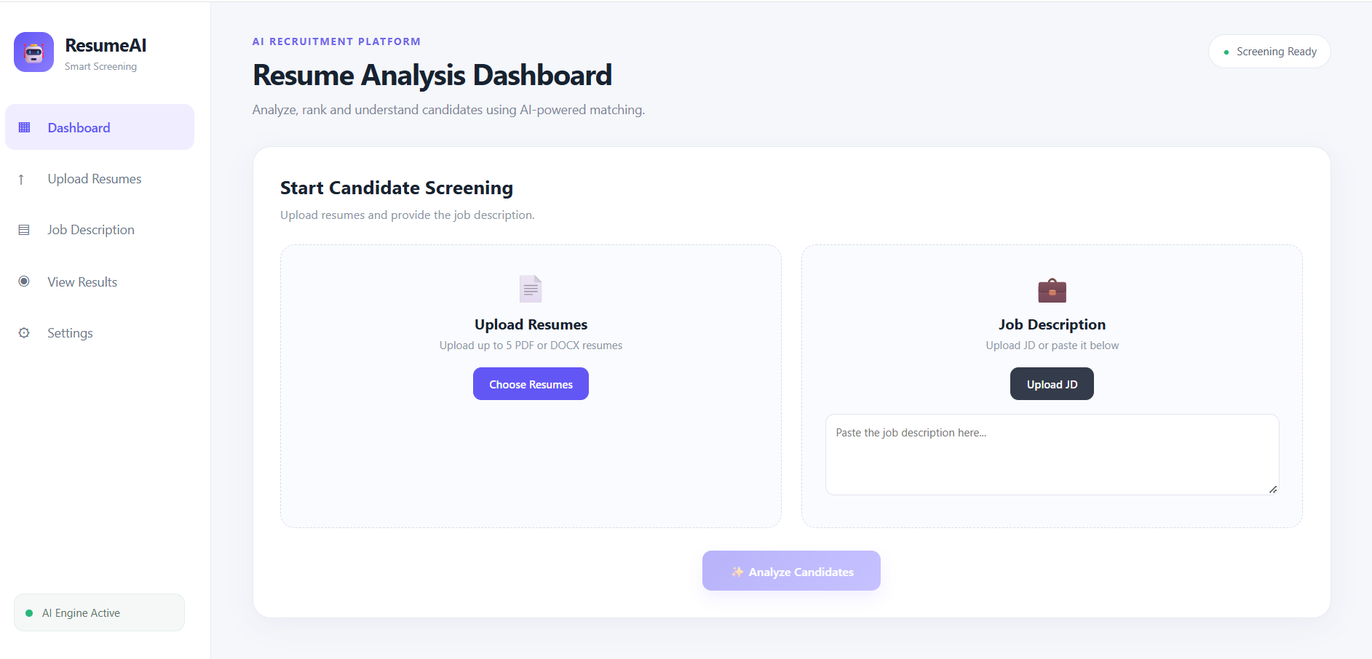

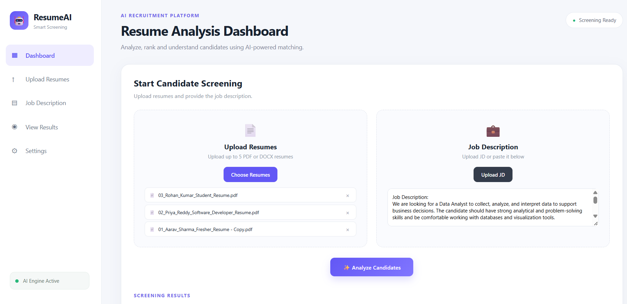

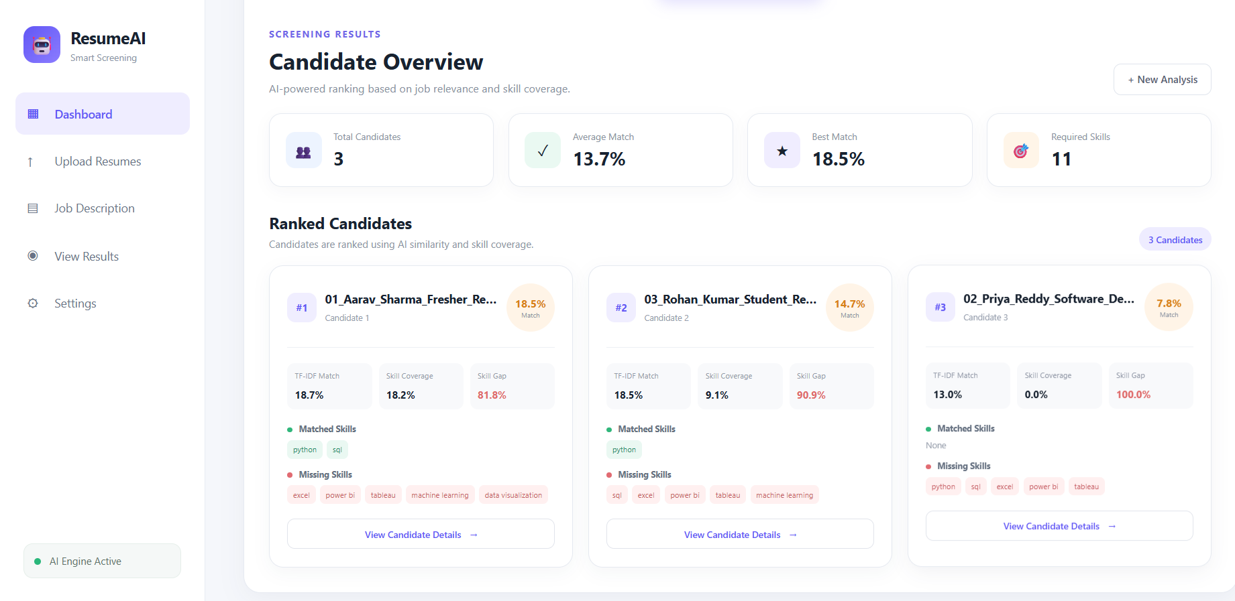

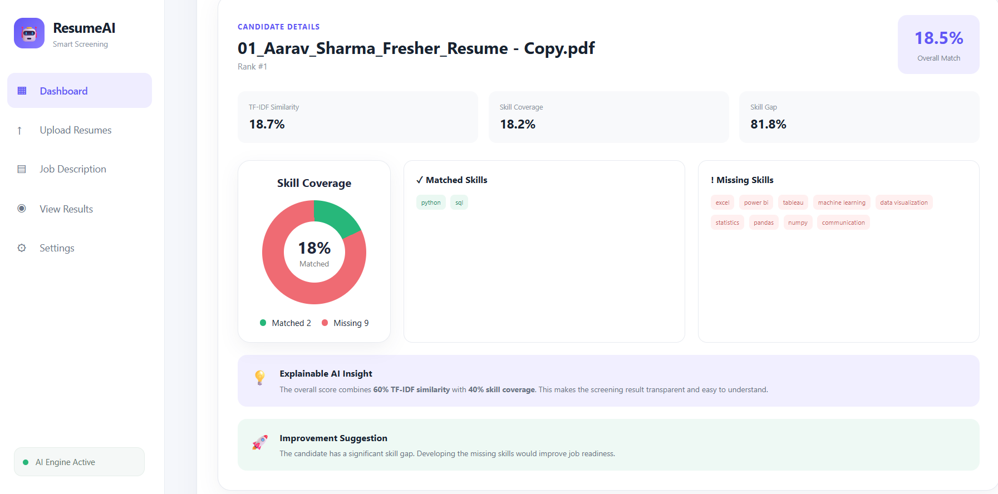

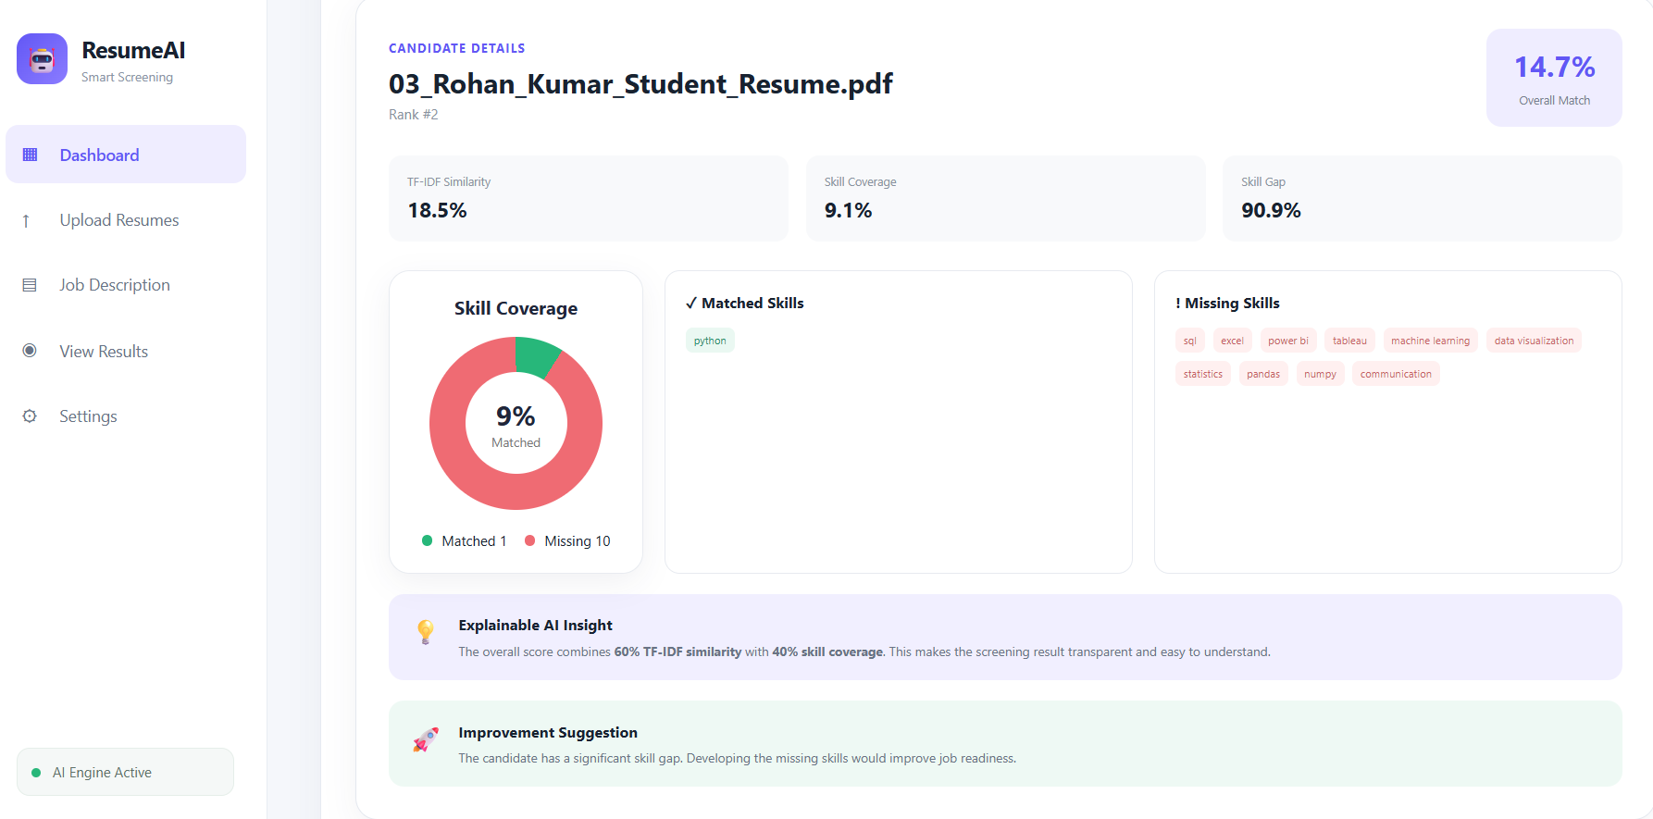

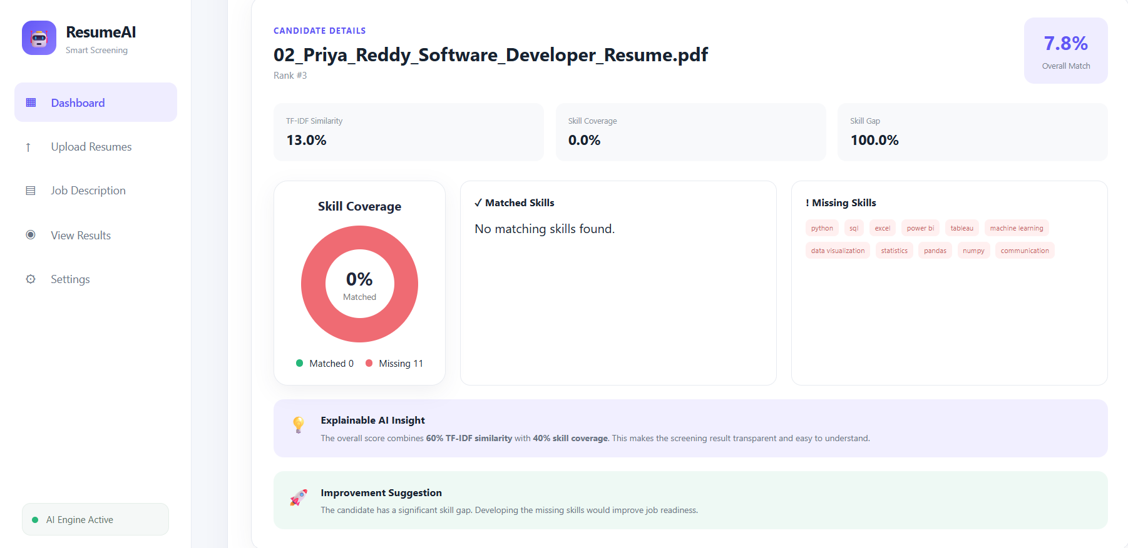

Testing and Test cases

Test Case No. | Name of the Test Case | Description | Expected Output | Actual Output | Pass/Fail
TC01 | Resume upload | Upload a valid resume in PDF/DOCX format. | Resume should be uploaded successfully. | Resume uploaded successfully. | Pass
TC02 | Resume parsing | Extract candidate details, education, experience, and skills from the resume | System should extract the required information correctly. | Resume details extracted successfully. | Pass
TC03 | Job description input | Enter a Data Analyst job description with required skills. | Job description should be accepted successfully. | Job description accepted successfully. | Pass
TC04 | Resume Screening | Compare resume skills with the required job skills.. | System should calculate a relevant match score. | Match score generated successfully. | Pass
TC05 | Skill Matching | Identify skills present and missing in the candidate's resume. | System should display matched and missing skills. | Matched and missing skills displayed successfully. | Pass
TC06 | Explainable AI analysis | Analyze the reasons behind the candidate's screening score.. | System should provide clear reasons for the score. | Key factors and reasons displayed successfully. | Pass
TC07 | Skill Gap Analysis | Identify skills required for the job but missing from the resume. | System should identify and categorize skill gaps. | Skill gaps identified successfully. | Pass
TC08 | Learning Recommendation | Generate recommendations based on the identified skill gaps. | System should suggest relevant skills/courses to learn. | Learning recommendations displayed successfully. | Pass

CONCLUSION AND FUTURE WORK

Conclusion

The AI-Based Explainable Resume Screening and Skill Gap Analysis System provides an efficient way to evaluate resumes against job requirements. The system extracts candidate skills, calculates a job-match score, identifies missing skills, and explains the reasons behind the result. It also provides learning recommendations to help candidates improve their skills. Thus, the system makes resume screening faster, more transparent, and useful for both recruiters and candidates.

Future Work

1. Improve AI accuracy for different resume formats.
2. Support multiple job roles and industries.
3. Add advanced NLP and Generative AI techniques.
4. Provide personalized course and career recommendations.
5. Add recruiter dashboards for candidate comparison and ranking.
6. Improve fairness and reduce AI bias in resume screening.
7. Integrate with job portals for real-time job matching.

REFERENCES

- V. Vapnik, The Nature of Statistical Learning Theory, Springer, 1995.
- C. D. Manning, P. Raghavan, and H. Schütze, Introduction to Information Retrieval, Cambridge University Press, 2008.
- T. Joachims, “Text Categorization with Support Vector Machines: Learning with Many Relevant Features,” Proceedings of ECML, 1998.
- S. Bird, E. Klein, and E. Loper, Natural Language Processing with Python, O'Reilly Media, 2009.
- F. Pedregosa et al., “Scikit-learn: Machine Learning in Python,” Journal of Machine Learning Research, Vol. 12, pp. 2825–2830, 2011.
- M. T. Ribeiro, S. Singh, and C. Guestrin, “Why Should I Trust You? Explaining the Predictions of Any Classifier,” Proceedings of the 22nd ACM SIGKDD International Conference, 2016.
- S. Lundberg and S. Lee, “A Unified Approach to Interpreting Model Predictions,” Advances in Neural Information Processing Systems (NeurIPS), 2017.
- J. Devlin, M.-W. Chang, K. Lee, and K. Toutanova, “BERT: Pre-training of Deep Bidirectional Transformers for Language Understanding,” Proceedings of NAACL-HLT, 2019.
- T. Brown et al., “Language Models are Few-Shot Learners,” Advances in Neural Information Processing Systems, 2020.
- F. Chollet, Deep Learning with Python, 2nd Edition, Manning Publications, 2021.

APPENDICES

S.No. | Appendix | Page No.
1 | System Screenshots | 16-19
2 | Implementation – Coding | 21
3 | Test Case Results | 33
4 | Sample Analysis Results | 35
5 | Sample Risk Assessment Report | 36

